LAB - 4

XR UNITY

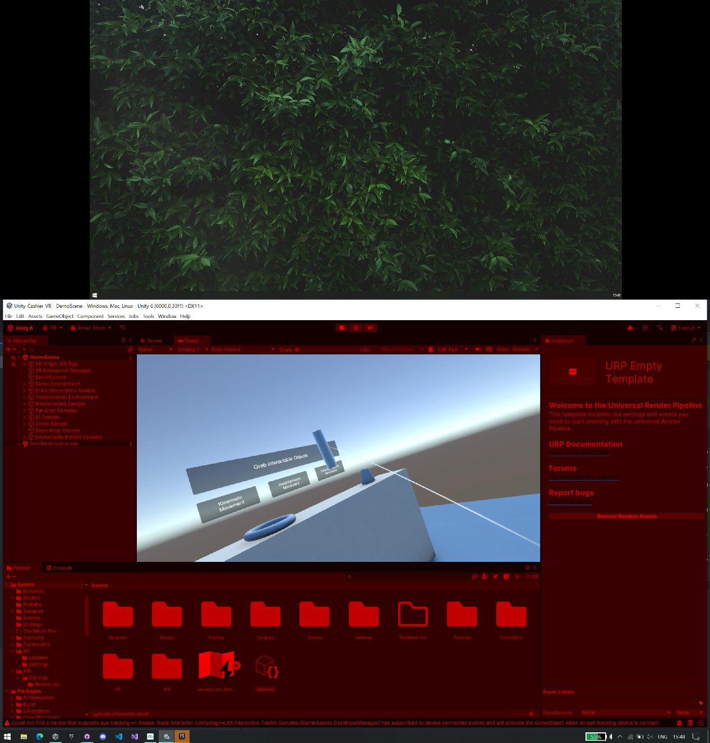

Fig 1.1: Interaction with Unity template demo

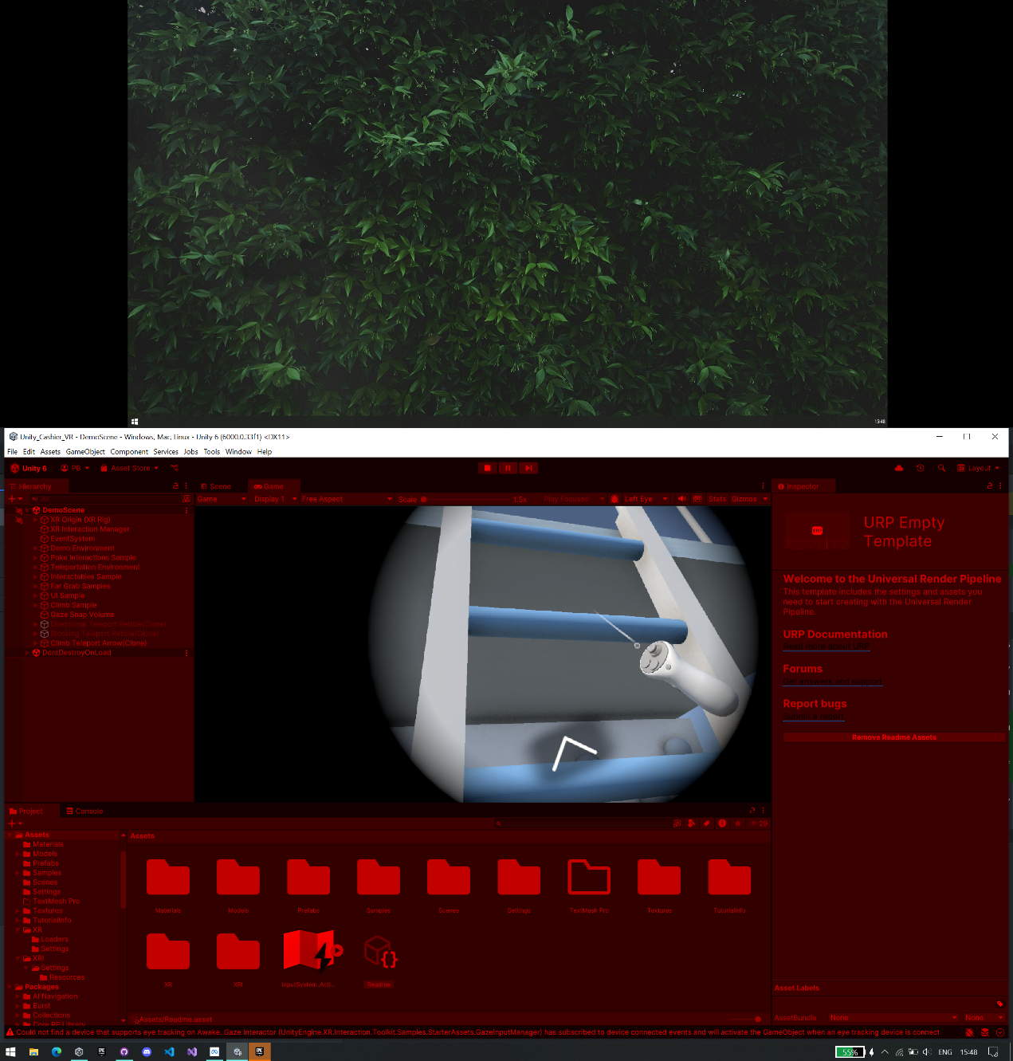

Fig 1.2: Interaction with Unity template demo for climbing

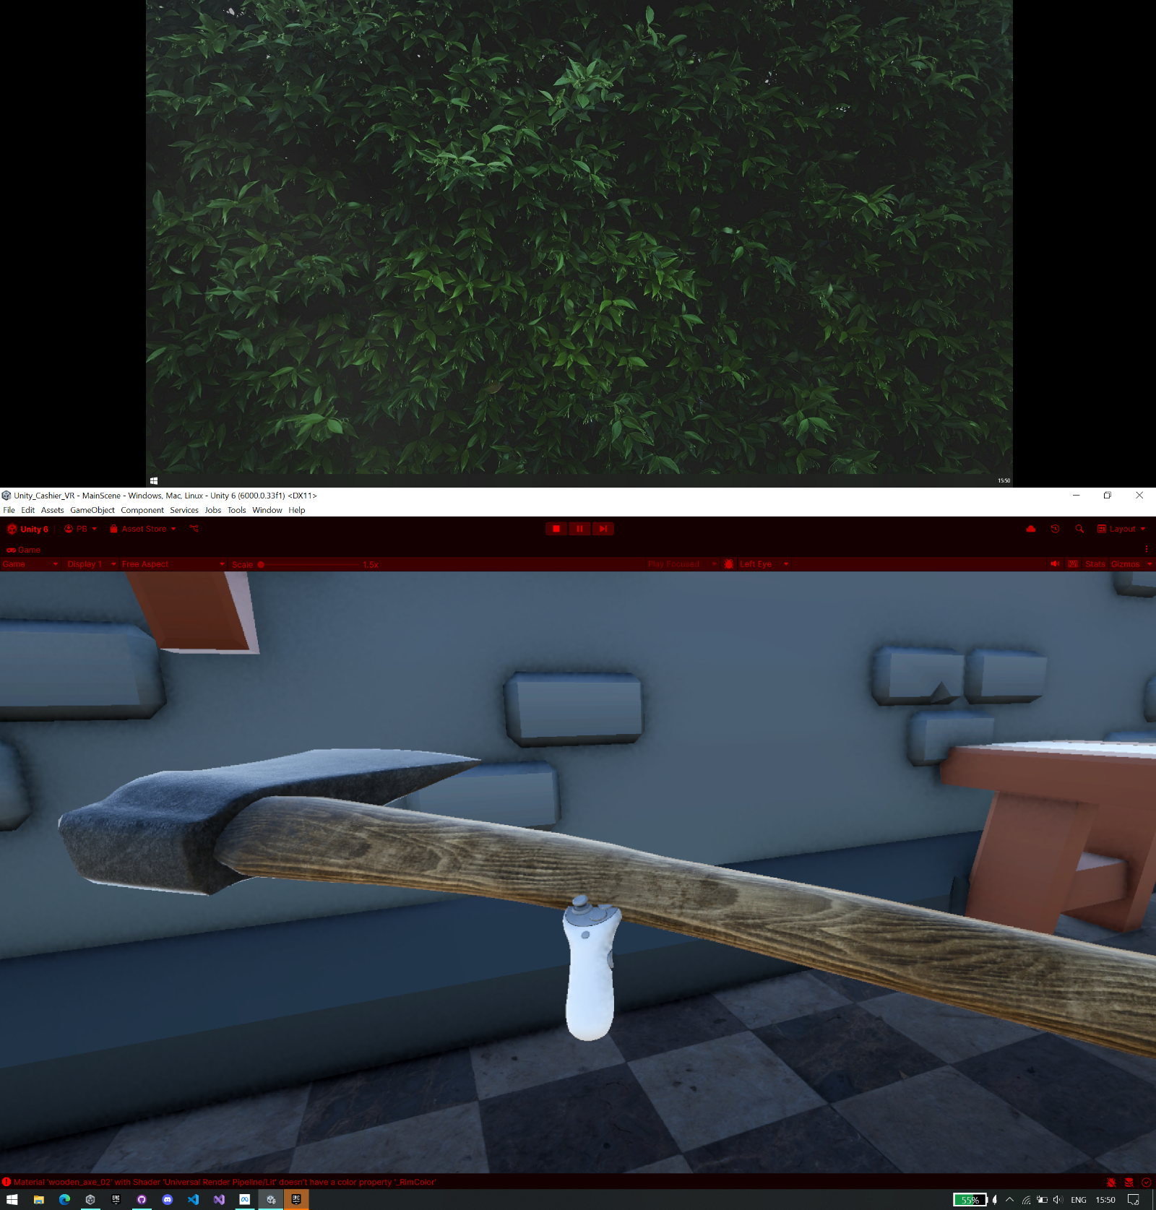

Fig 1.3: Interaction with Custom Scene from our Studio Test Scene

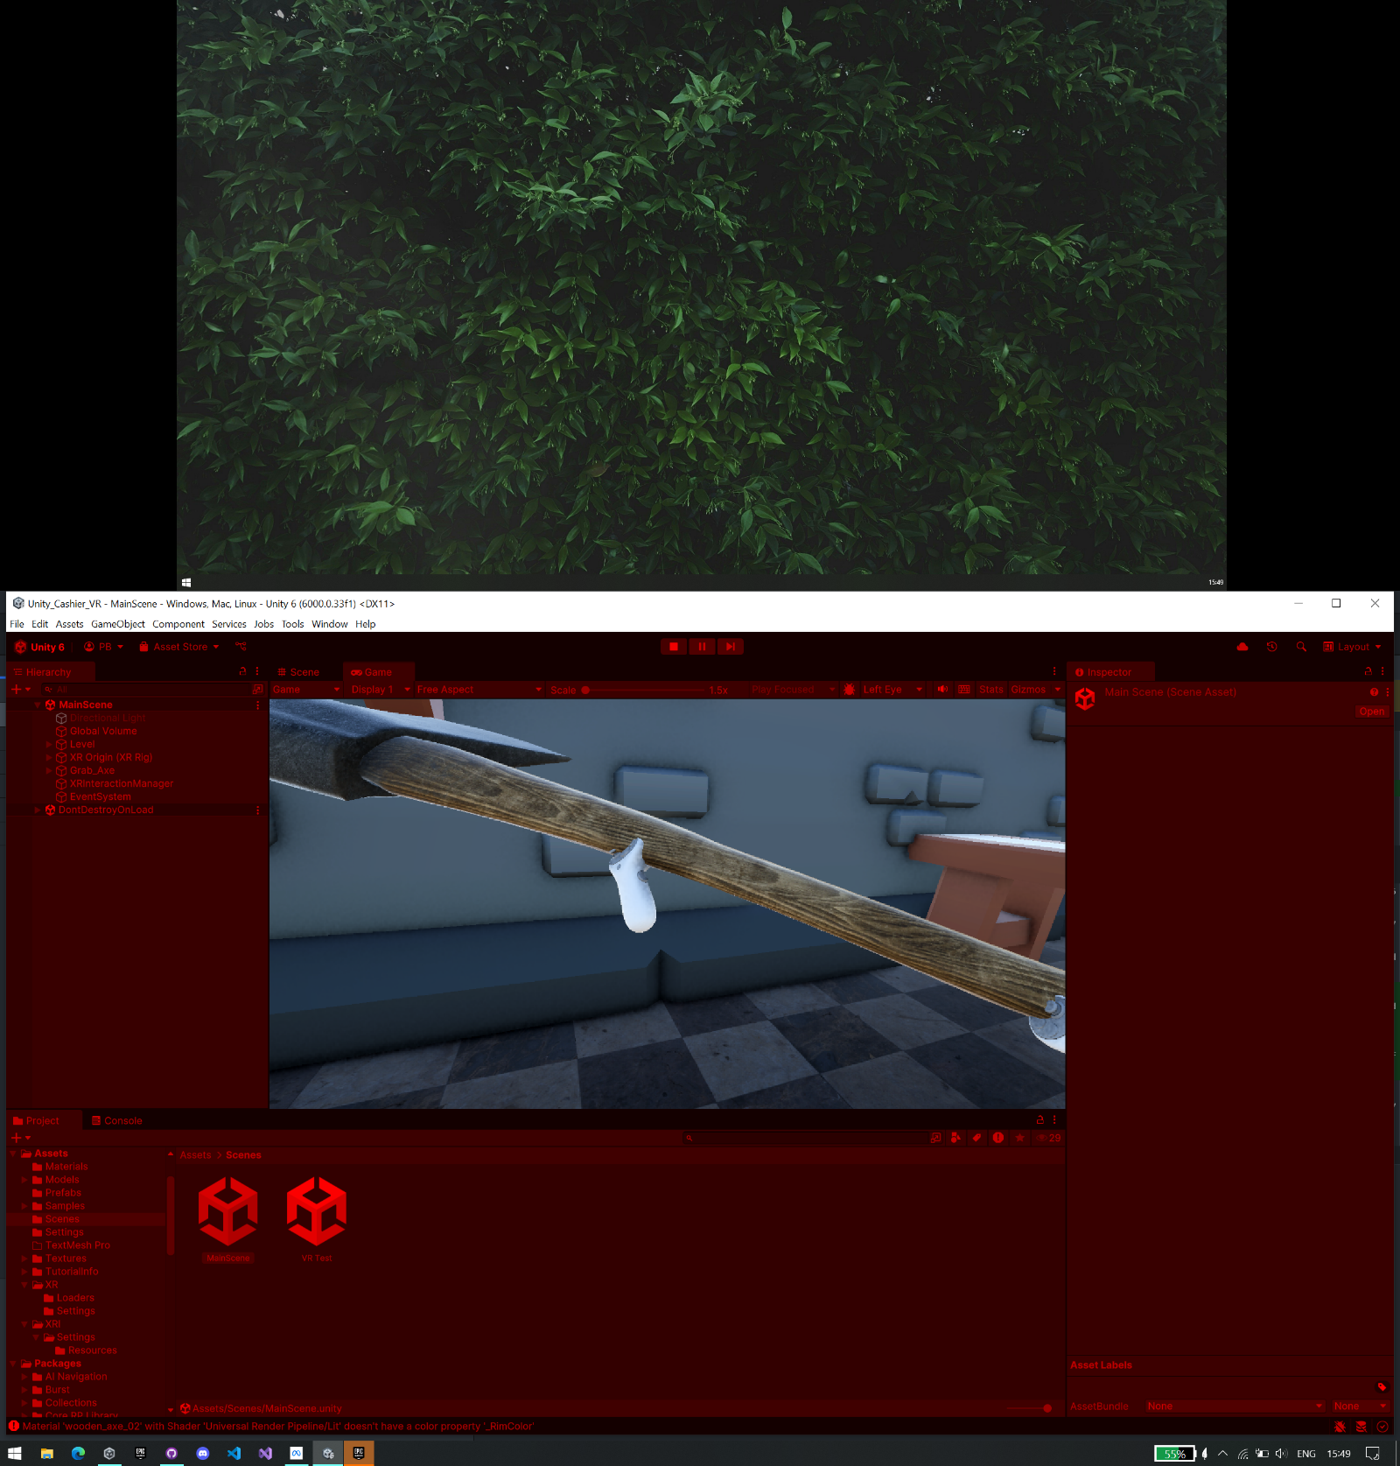

Fig 1.4: Interaction with Custom Scene from our Studio Test Scene, Dual Hand

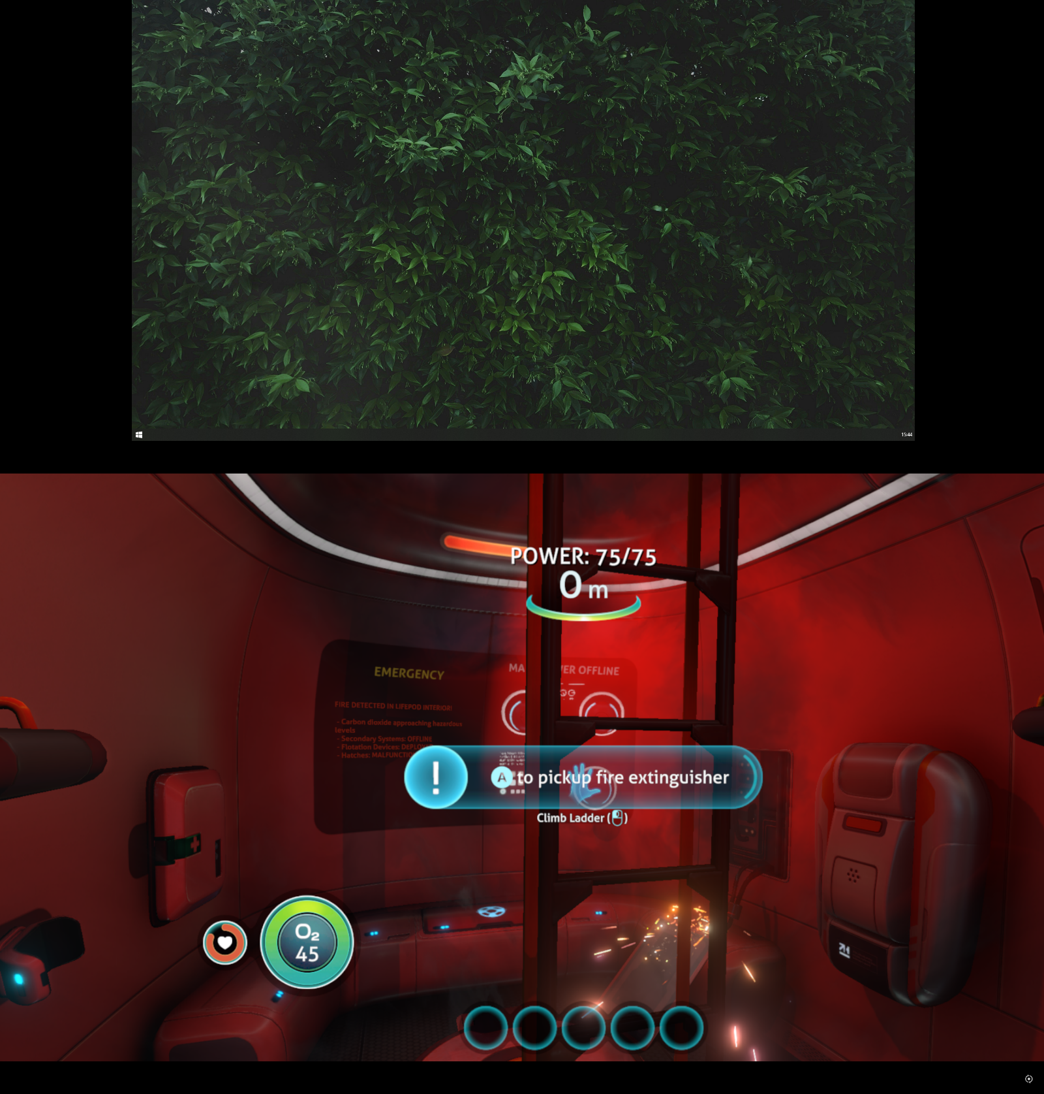

Fig 1.5: Interaction with Subnautica game

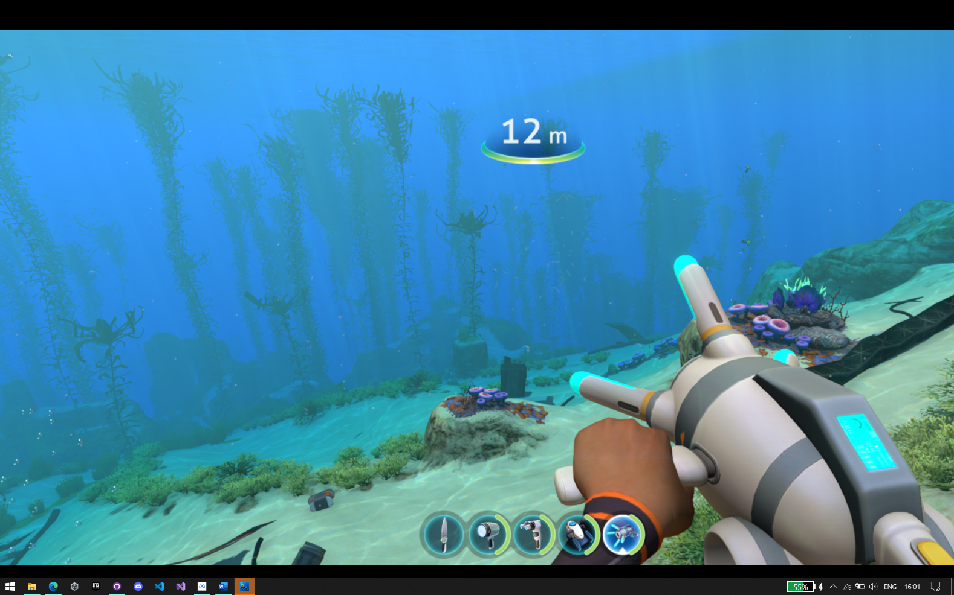

Fig 1.6: Interaction with Subnautica game

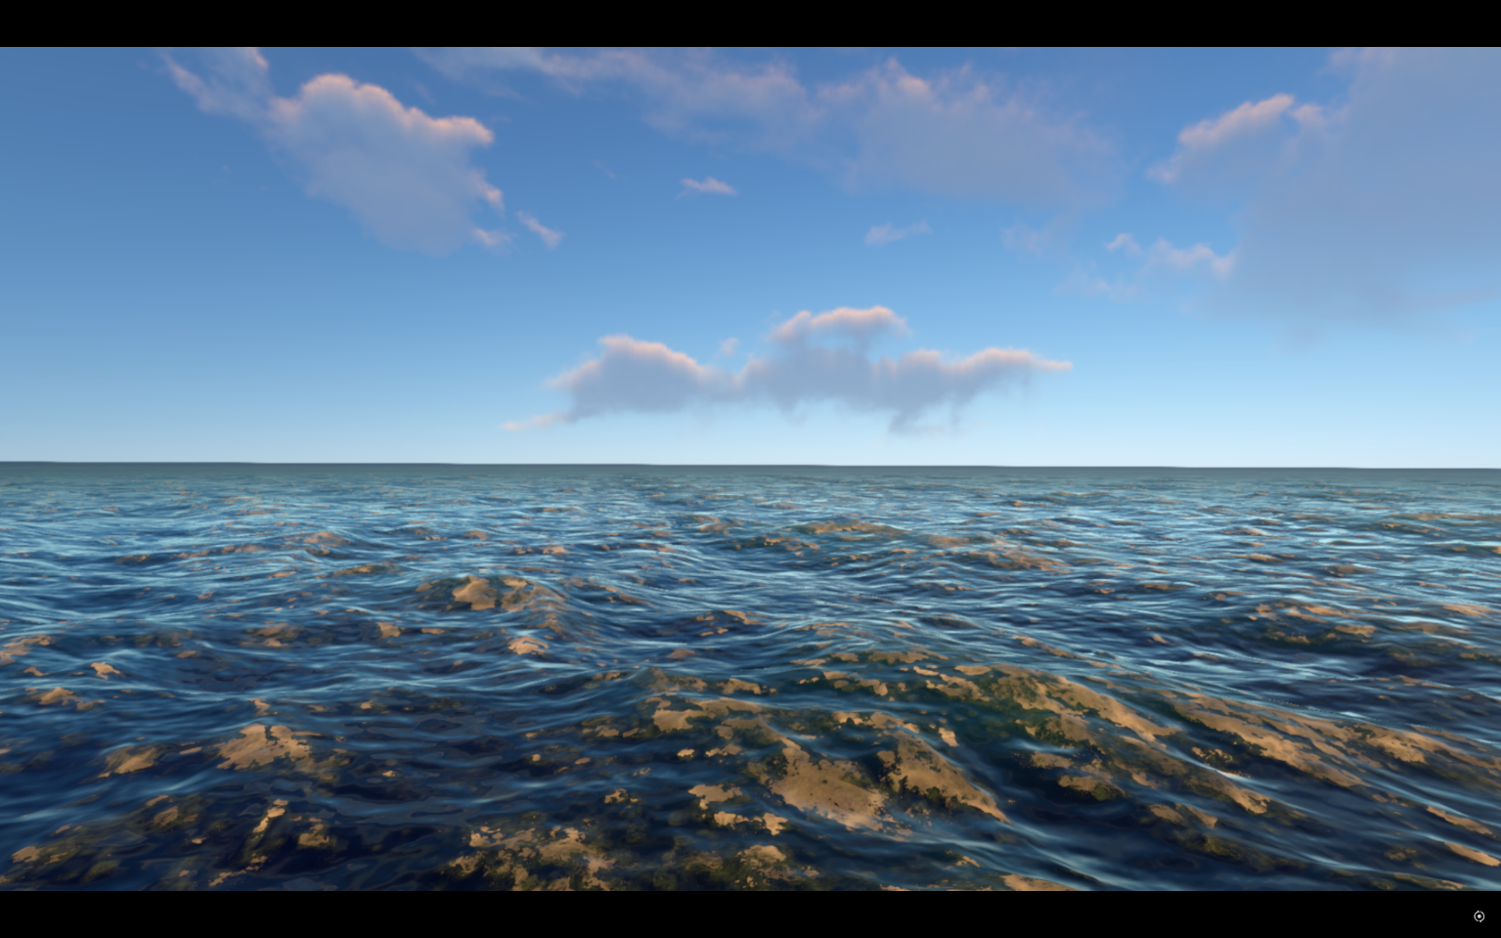

Fig 1.7: Exploration with Subnautica game

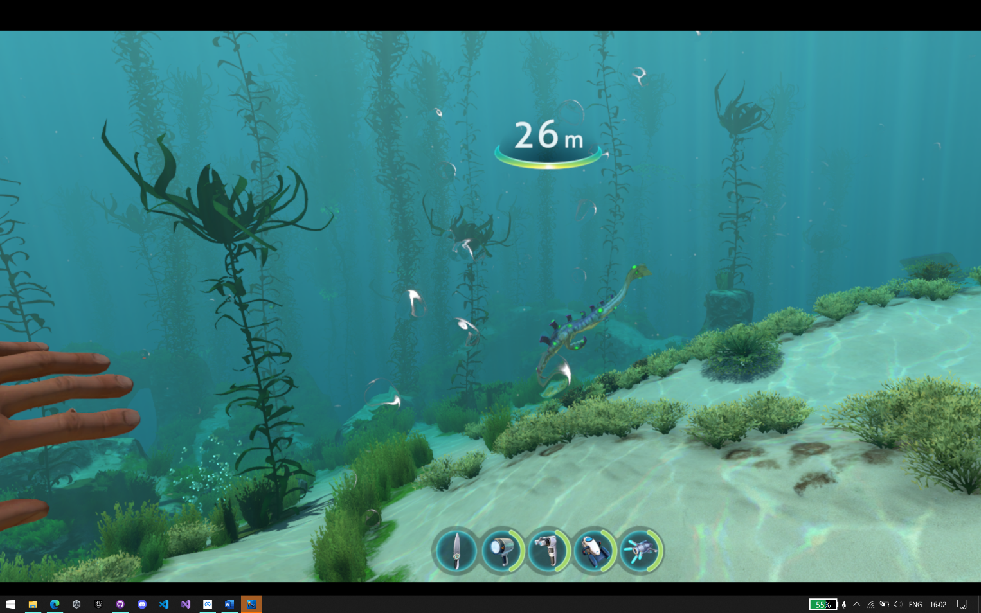

Fig 1.8: Exploration with Subnautica game